**SEQUENCE LISTING APP GUIDELINES**

Contents

1 GENERAL INFORMATION 1

2 PRE-PROCESSING 1

3 POST-PROCESSING 6

4 VALIDATION OF XML SEQUENCE LISTINGS 7

5 POSSIBLE ERROR MESSAGES 7

6 CONVERT TRANSLATED XML INTO A TXT HUMAN READABLE FILE 10

# GENERAL INFORMATION

SeproTec’s Localization Team has developed an App in order to manage the translation process of WIPO’s Sequence Listings in XML formatting.

The localization procees is done using specific tool “Sequences_WIPO.exe” developed by Localization team and used by PM to prepare the sequences.xml file and WIPO Sequence Tool used by localization to verify final XML or do other specific tasks.

# PRE-PROCESSING

The PM will have to follow the steps below:

* The latest Studio template must be installed as only this version will categorize the XML in Studio as a WIPO document in the file type.
* The PM will have to open the App “Sequences_WIPO.exe”, drop the source XML in the corresponding field and select the target languages needed (they can be selected one after another). Once that is done, please select “Prepare file”. Ensure you have the latest version of the tool. Currently 1.1.0.7 or greater

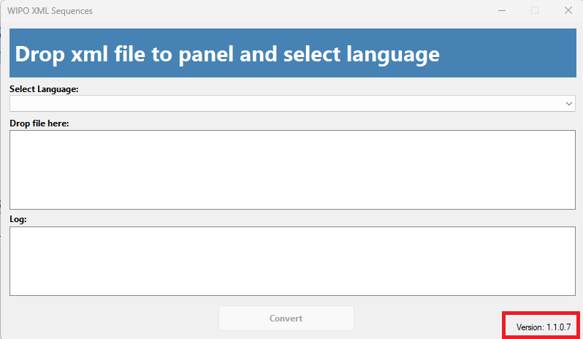

Once that is done, the App will create a “Totrans” XML for each language combination , save them in the same folder where the source XML was saved, confirm the completion of the process and ask the PM to NOT TO RENAME the XMLs created:

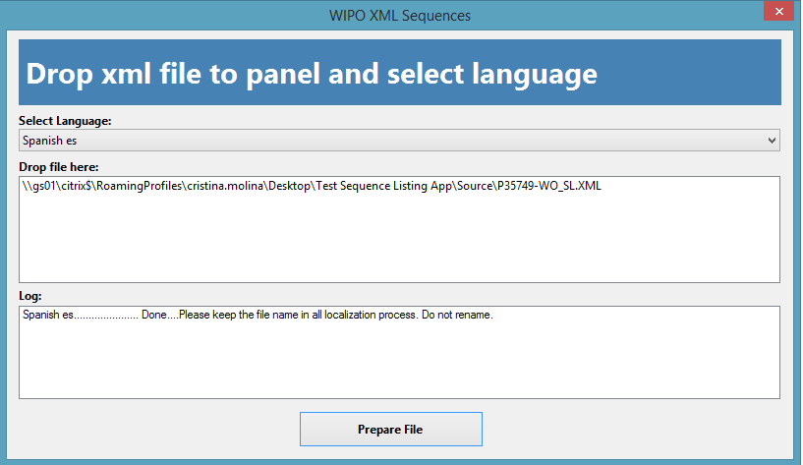

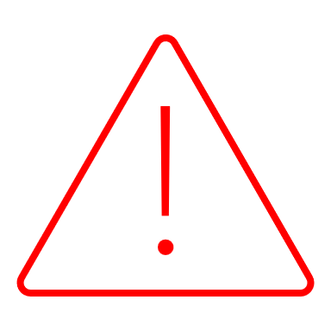

Important!: If you rename filename the post process step will fail!!

ZH-TW Special case: if selected language is zh-tw the macro will not generate qualifiers to be translated. We will translate only title, applicant and inventor name: According to the IPO's recent announcement (<https://topic.tipo.gov.tw/patents-tw/cp-750-922148-73750-101.html>), **ONLY the "title of the invention," "applicant," and "inventor" should be translated into Chinese; translations of other parts are unnecessary**. So 09/19/2023 this change was implemented to version 1.1.0.0

When language is zh-tw message in log details this issue.

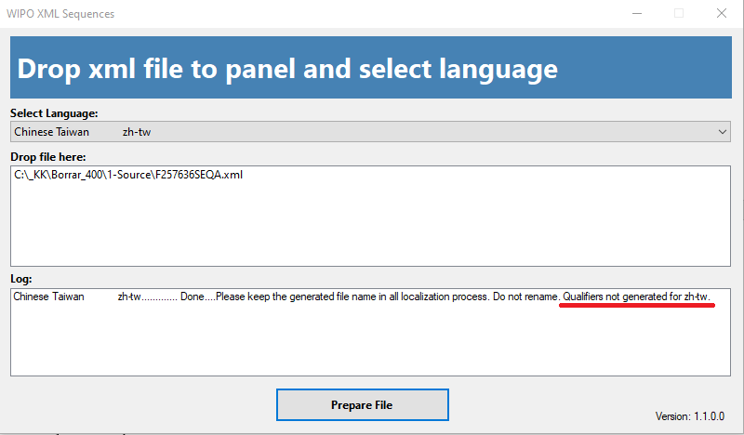

All the other languages will generate qualifiers for localization.

Once all XMLs are created, the PM will have to import them all in Studio using Patents template equal or after April 23th and delete the unnecessary documents in each target language. Also ensure correct WIPO file type has been applied automatically.

File Type for Trados 2021 will be WIPO_21 and for Trados 17-19 will be WIPO_17-19.

In Spanish for example, the CN XML will have to be deleted:

For Trados 2017-2019



For Trados 2021





Important!: If File Type in your project is not one of showed in screenshot ask Localization team!

That document will have to be sent to the translator included in the translation package together with the rest of the documents that require translation.

TIP:

There is Studio add-in that automatically detects the language based on file name; it is only available for Trados 2021.

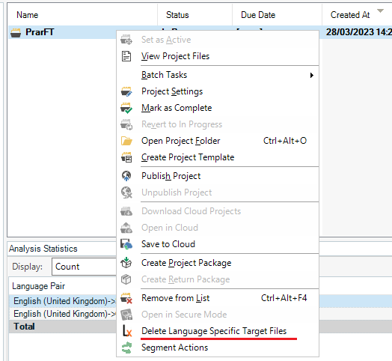

This will automatically delete non desired files on target Studio folders.

# POST-PROCESSING

* Once the project is finalized, the “Totrans” XMLs will have to be imported back to the App.

Drop “Totrans” file into panel and this time, the App will indicate “Post-process” in button, and the header will change color and text to “Drop xml file to panel and click Post Process button”.

Once clicked “Post Process” button macro will automatically create a copy of the Sequences XML renamed as “FINAL”.

The FINAL named XMLs are for delivery to client, rename them as the original XML we imported in the App during the pre-processing step:

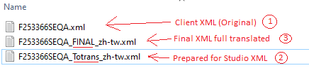

This post-processing step is necessary due to the fact that Studio changes the “**UTF**-8” appearing in the source XML by “**utf**-8” and the client would get error messages if that issue is not fixed before delivery:

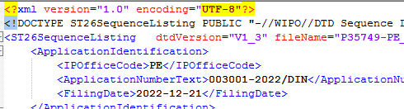

# VALIDATION OF XML SEQUENCE LISTINGS



**IMPORTANT!**

As this App is in a testing phase, the PM will have to send all final XMLs to the L10N Team before delivery so that they can be validated in the WIPO’s Sequence Listing Tool as well.

# POSSIBLE ERROR MESSAGES

The PM could get following error messages, it could occurs in the app or in Trados Studio:

**IN THE APP:**

* **Wrong encoding**: This App has been created for WIPO’s Sequence Listings in XML format with English as source text. When the source XML have a different encoding as in the example below, the App will show an error message asking PM to contact the Localization Team. When this occurs, the app will exit.

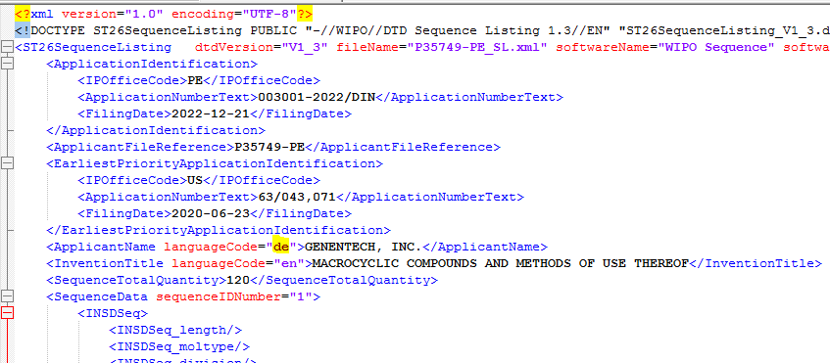

Error showed is like this and shows the problematic language code

* **No WIPO XMLs**: Shouldn’t the original XML be a WIPO XML or xml version is incorrect, the App will send an error message to the PM and program exit.

**IN STUDIO:**

* **While dropping files to be translated into Studio:** You can get a similar error from Studio like this. Contact Localization team.

# CONVERT TRANSLATED XML INTO A TXT HUMAN READABLE FILE

Sometimes client wants final translated XML converted into .txt human readable file. This can be done using WIPO Sequence tool. It is very rare that client request this but sometimes has been requested. Maybe the client send a .txt to be translated after the XML has been translated but you can ignore it and generate the .txt based on xml file.

1-Import translated XML in WIPO sequence tool.

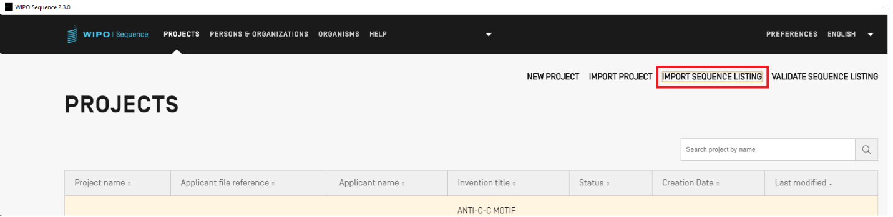

2-Once Imported click on “Generate Sequence Listing” and save the file.

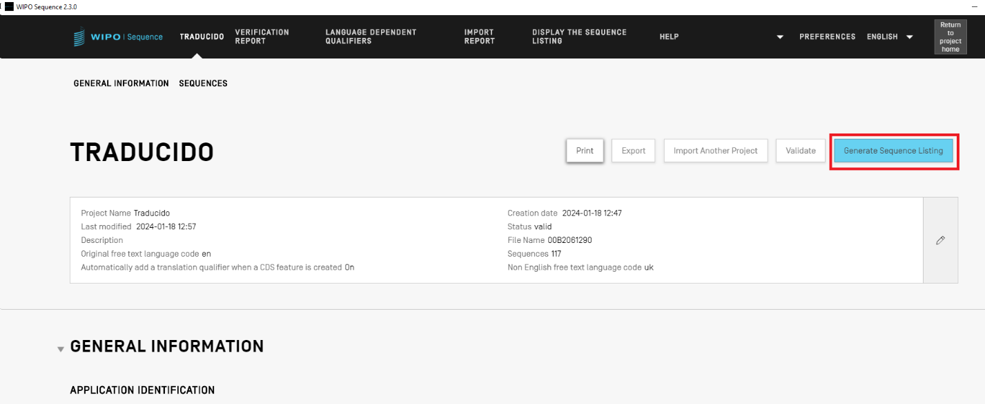

3-Then click on “DISPLAY THE SEQUENCE LISTING” on main menu

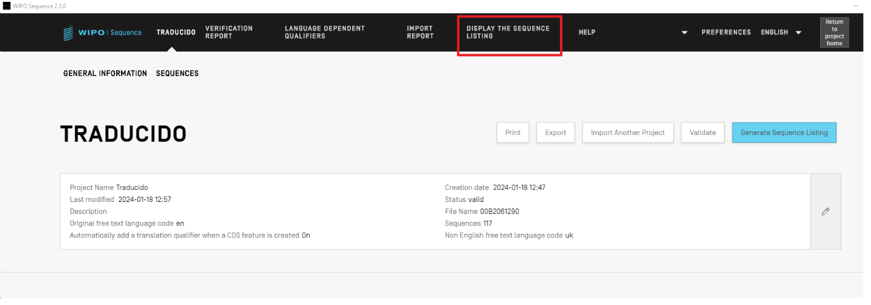

4-Then click on “Export Sequence Listing as .txt file” and save the file.

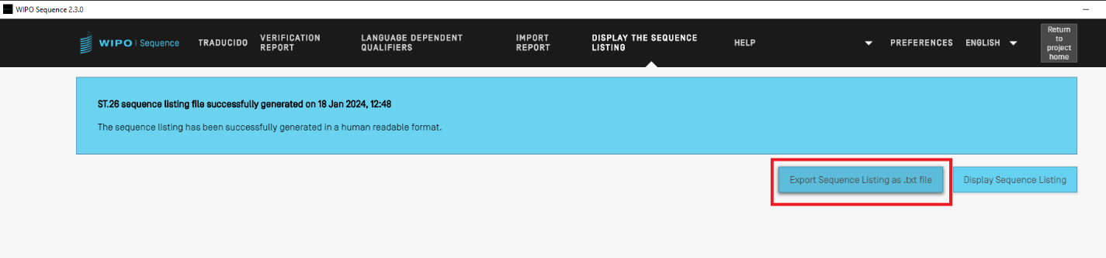

A human readable .txt file will be created.

